

**4G**

4G products

LT220

product specification

REV 7.10.09005

Product information

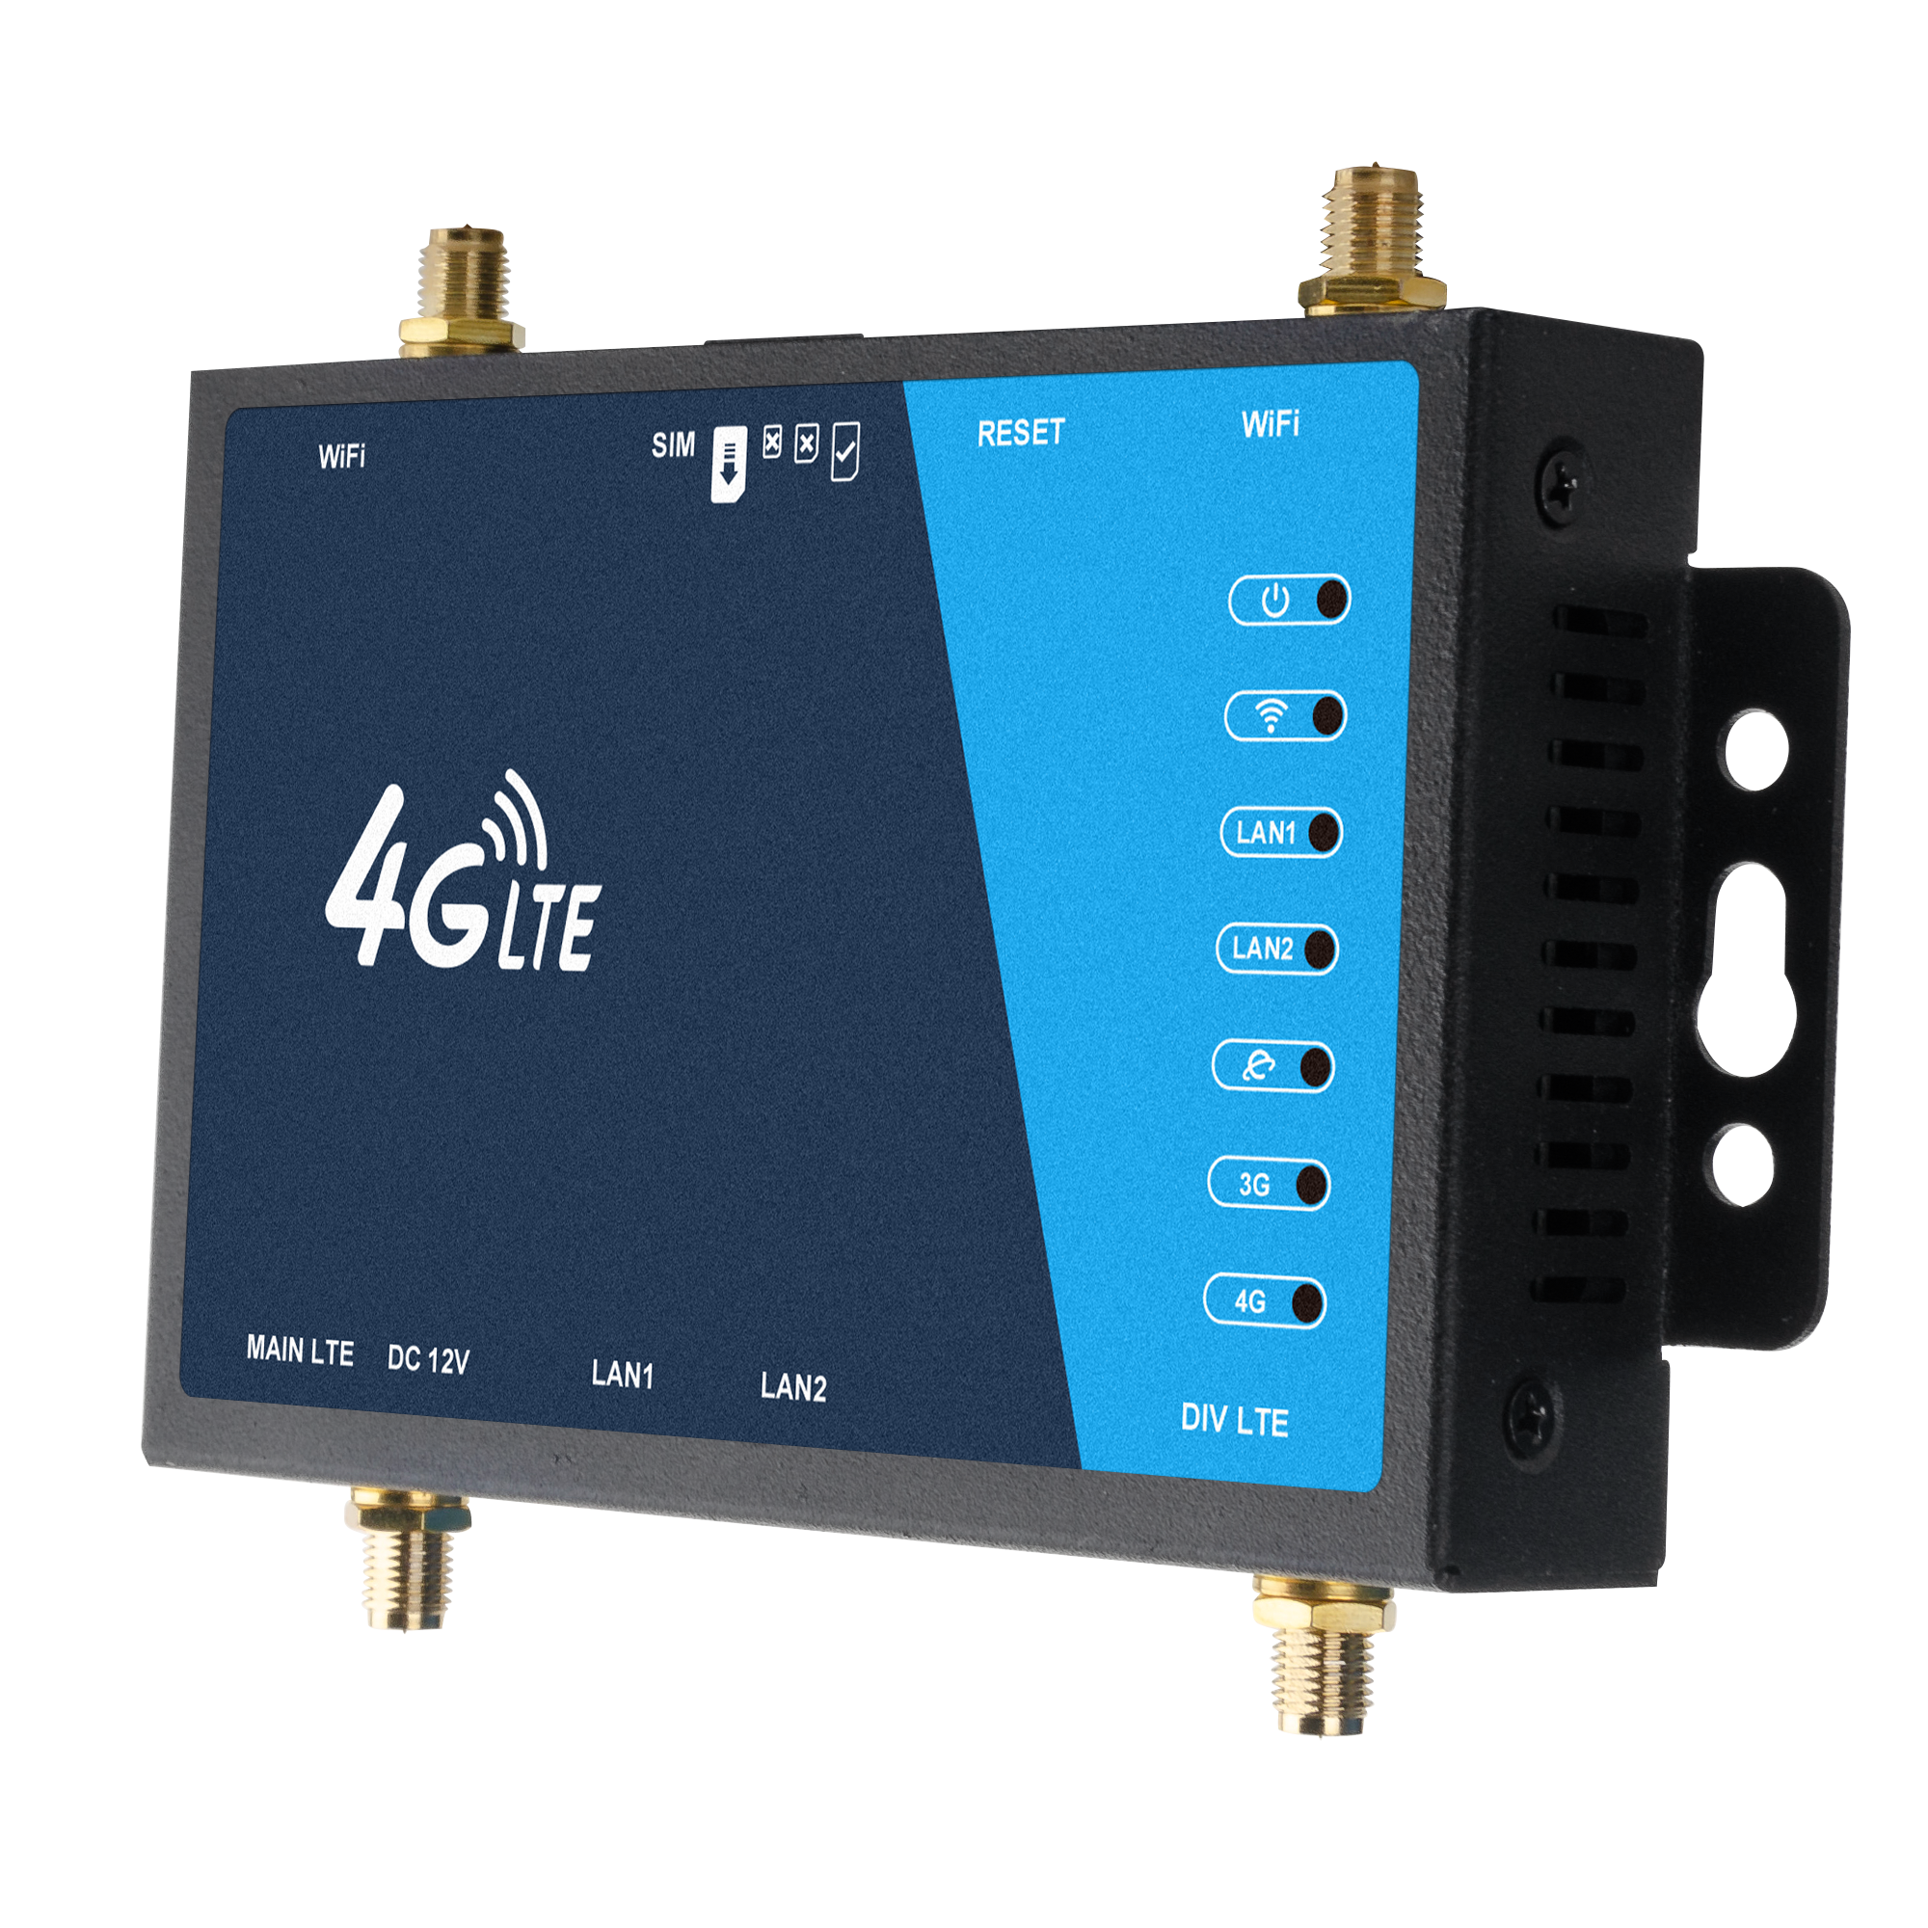**Product Brief**

This device is a high-performance 4G broadband wireless router, supporting the maximum DL / UL rate of 150 / 50Mbps. it provides high-quality data communication and optimized Wi-Fi data transmission. Diversified Wi-Fi standards and encryption modes ensure the safety and stability of the product.

With a variety of working modes (4G to Wi-Fi / 4G to cable), rich network protocols and reliable connections, it can be widely used in business and home. It has the function of regular restart and firewall protection. The built-in hardware watchdog can effectively prevent the system from crashing during operation. Built in dual firmware can automatically recover the system due to software upgrade failure or abnormal startup caused by software.

**Product specification**

* Dual network interface design, can provide wired network for other equipment.
* Plug in the SIM card to easily provide a network for the device.
* Regular restart and firewall protection
* Built in hardware watchdog, built-in dual firmware, stable operation.

**Appearance display**

|  |  |
| --- | --- |
| F:\庄晓彬\产品白底图汇总\LT220_4G小铁壳\1-assets\2000PX.png2000PX | F:\庄晓彬\产品白底图汇总\LT220_4G小铁壳\2-assets\2000PX.png2000PX |
| F:\庄晓彬\产品白底图汇总\LT220_4G小铁壳\5-assets\2000PX.png2000PX | F:\庄晓彬\产品白底图汇总\LT220_4G小铁壳\8-assets\2000PX.png2000PX |
| F:\庄晓彬\产品白底图汇总\LT220_4G小铁壳\6-assets\2000PX.png2000PX | F:\庄晓彬\产品白底图汇总\LT220_4G小铁壳\7-assets\2000PX.png2000PX |

**Background management interface**

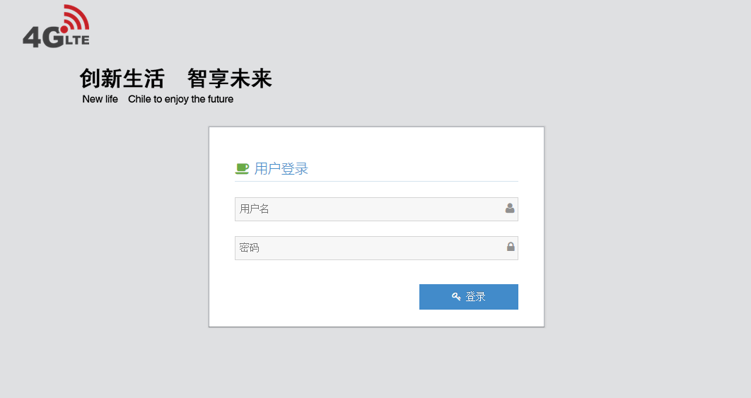

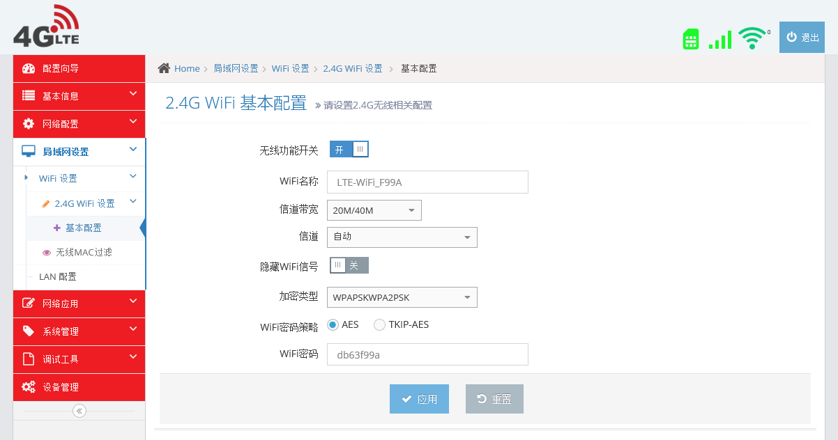

The above screenshots are for reference only. If there is any change, please refer to the actual display.

**Specification parameter**

|  |  |  |
| --- | --- | --- |
| Interface | Network | 2\*lan |
| SIM | 2FF sim |
| Button | reset |
| DC adapter | Input voltage:12V 1A |
| Solution | Routing and Wi-Fi chipset supplier | MTK |
| BASE | Routing and Wi-Fi chipset model | MT7628N |
| Routing and Wi-Fi processor info | IEEE 802.11 /b/g/n |
| DDR/SPI | 64MBytes/16MBytes |
| RF | Main antenna/主要天线 | Internal antenna |
| Receive diversity antenna/接收天线 | Internal antenna |
| Wi-Fi band/无线频段 | 2400MHz-2483.5MHz |
| MIMO for Wi-Fi | 3dbi X 2 |
| Max. transmitter power for Wi-Fi | 802.11b 24dBm±2dBm;  802.11g 16dBm±2dBm;  802.11n 15dBm±2dBm; |
| Software | Language | Chinese English |
| APN Setting | Supported |
| Device Settings | Supported |
| WIFI Settings | Supported |
| Routing Settings | Supported |
| Firewall Settings | Supported |
| Technical standard | LED | Supported |
| Wi-Fi standard/ | 802.11b/g/n(2\*2 11n features) |
| Wi-Fi security | WPA/WPA2 |
| OS | Windows XP、Windows Vista、Windows 7、Windows 10、MAC、Linux |
| Browser | IE (8.0 and later)、Firefox (3.0 and later)、Safari (4.0 and later)、Opera (10.0 and later)、Chrome (10.0 and later) |
| Environment | Operating temperature | 0 to 50° C |
| Storage temperature | -40 to 70° C |
| Humidity | 5% to 95% |

**Module information**

|  |  |
| --- | --- |
| **Solution ASR CAT4** | |
| Interface | LCC |
| Size | 29.0 × 32.0 × 2.4mm |
| Wireless chipset supplier | ASR |
| Wireless chipset model/ | 1803S |
| Wireless processor info | CAT4 |
| USIM/SIM slot | Standard 6 PIN SIM card interface 3V SIM card and 1.8V SIM card |
| Operating temperature/ | -35 to 75° C |
| Storage temperature | -40 to 90° C |

|  |  |
| --- | --- |
| Optional frequency band | |
| ML352-JC3 | LTE:B1 / B3 / B5 / B8 / B34 / B38 / B39 / B40 / B41; WCDMA:B1 / B5 / B8 |
| ML352-JD3-AE | FDD:B1 / B3 / B5 / B7 / B8 / B20; TDD:B38 / B40 / B41; WCDMA:B1 / B5 / B8 |
| ML352-JD3-AFL | FDD:B1 / B3 / B5 / B7 / B8 / B20 / B28; TDD:B38 / B40 / B41; WCDMA:B1 / B5 / B8 |
| ML352-JD3-AU | FDD: B1 / B2 / B3 / B4 / B5 / B7 / B8 / B12 / B17 / B28 / B66;  TDD:B38 / B40 / B41;WCDMA:B1 / B2 / B4 / B5 / B8 |

|  |  |
| --- | --- |
| **Solution Qualcomm 9607 CAT4** | |
| Interface | LCC |
| Size | 29.0 × 32.0 × 2.4mm |
| Wireless chipset supplier | Qualcomm |
| Wireless chipset model | 9607 |
| Wireless processor info | CAT4 |
| USIM/SIM slot | Standard 6 PIN SIM card interface 3V SIM card and 1.8V SIM card |
| Operating temperature | -35 to 75° C |
| Storage temperature | -40 to 90° C |

|  |  |
| --- | --- |
| Optional frequency band 可选频段 | |
| ML358-TD3 | FDD: B2 / B3 / B4 / B5 / B7 / B8 / B12 / B13 / B17 / B25 / B26 / B66; TDD: B41;  WCDMA:B2 / B4 / B5 / B8 ; GSM:850,900,1800,1900 |
| ML358-FA3 | FDD: B2 / B3 / B4 / B5 / B7 / B8 / B12 / B13 / B17 / B25 / B26 / B66 / B71;  TDD:B41 (2496MHz-2690MHz) ; WCDMA:B2 / B4 / B5 / B8 ; GSM:850,900,1800,1900 |
| EC25-AF | LTE:B2 / B4 / B5 / B12 / B13 / B14 / B66 / B71 ; WCDMA:B2 / B4 / B5 |
| EC25-AU | FDD: B1 / B2 / B3 / B4 / B5 / B7 / B8 / B28; TDD: B40; WCDMA: B1 / B2 / B5 / B8;  GSM:B2 / B3 / B5 / B8 |
| EC25-E | FDD:B1 / B3 / B5 / B7 / B8 / B20 ; TDD:B38 / B40 / B41 ; WCDMA:B1 / B5 / B8 ; GSM:B3 / B8 |

|  |  |
| --- | --- |
| **Solution/方案 ASR CAT6** | |
| Interface | PCIE |
| Wireless chipset supplier | ASR |
| Wireless chipset model | 1826 |
| Wireless processor info | CAT6 |
| USIM/SIM slot | Standard 6 PIN SIM card interface 3V SIM card and 1.8V SIM card |
| Operating temperature | -35 to 75° C |
| Storage temperature | -40 to 90° C |

|  |  |
| --- | --- |
| Optional frequency band 可选频段 | |
| EG060V-EA | LTE-FDD: B1 / B3 / B5 / B7 / B8 / B20 / B28 ;  LTE-TDD: B38 / B40 / B41 ; 2 × CA②: B1 + B1 / B3 / B5 / B8 / B20 / B28 ;  B3 + B3 / B5 / B7 / B8③ / B20 / B28 ;  B7 + B5 / B7 / B8 / B20 / B28 ;  B38 + B38; B40 + B40; B41 + B41 WCDMA: B1 / B5 / B8 |

|  |  |
| --- | --- |
| **Solution Qualcomm CAT6** | |
| Interface | PCIE |
| Wireless chipset supplier | Qualcomm |
| Wireless chipset model | EP06 |
| Wireless processor info | CAT6 |
| USIM/SIM slot | Standard 6 PIN SIM card interface 3V SIM card and 1.8V SIM card |
| Operating temperature | -35 to 75° C |
| Storage temperature | -40 to 90° C |

|  |  |
| --- | --- |
| Optional frequency band | |
| EP06-E | LTE-FDD: B1 / B3 / B5 / B7 / B8 / B20 / B28 / B32  LTE-TDD: B38 / B40 / B41  2×CA: B1+B1 / B5 / B8 / B20 / B28;  B3+B3 / B5 / B7 / B8 / B20 / B28;  B7+B5 / B7 / B8 / B20 / B28;  B20+B32; B38+B38; B40+B40; B41+B41  WCDMA: B1 / B3 / B5 / B8 |
| EP06-A | LTE-FDD: B2 / B4 / B5 / B7 / B12 / B13 / B17 / B25 / B26 /  B29 / B30 / B66  LTE-TDD: B41  2×CA: B2+B2 / B5 / B12 / B13 / B17 / B26 / B29;  B4+B4 / B5 / B12 / B13 / B17 / B26 / B29;  B7+B5 / B7 / B12 / B13 / B17 / B26 / B29;  B25+B5 / B12 / B13 / B17 / B25 / B26 / B29;  B30+B5 / B12 / B13 / B17 / B26 / B29;  B66+B5 / B12 / B13 / B17 / B26 / B29 / B66;  B41+B41  WCDMA: B2 / B4 / B5 |
| EP06-LA | LTE-FDD: B2 / B3 / B4 / B5 / B7 / B8 / B20 / B28  2×CA: B2+B2 / B5 / B8 / B20 / B28;  B3+B3 / B5 / B7 / B8 / B20 / B28;  B4+B4 / B5 / B8 / B20 / B28;  B7+B5 / B7 / B8 / B20 / B28  WCDMA: B2 / B3 / B4 / B5 / B8 |

The above are common frequency bands, which can be customized according to the module needs!